**Download the update executable file from :**

https://drive.google.com/drive/folders/1zEAY5J8Y3jtM11oqNecVipoKpSL0pPDs?usp=sharing

Source File -->"Download Ads.py"

Dependencies-->pytube , json

Executable File :

dist-->Download Ads.exe

Will download Videos in same folder only , Json File will get updated automatically .

How To Run :

Dist-> Double Click On Download Ads.exe

"It will ask for URL or Video Id or Debug Info "

Press 1 if you have URL and then Enter the URL ,

Press 2 if you have VideoID and then Enter the VideoID .

How to get VideoID :

1. Right click on Video and select “Stats For Nerds”

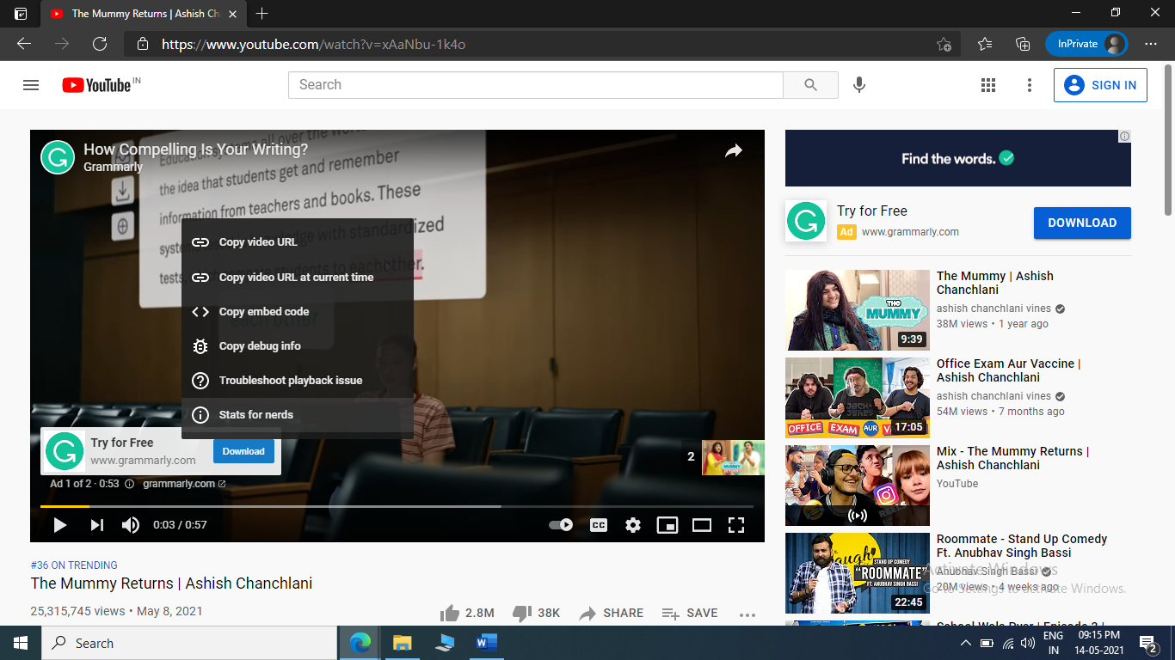

1. Type in the VideoID :  
   For Example : zADj0k0waFY in this case .

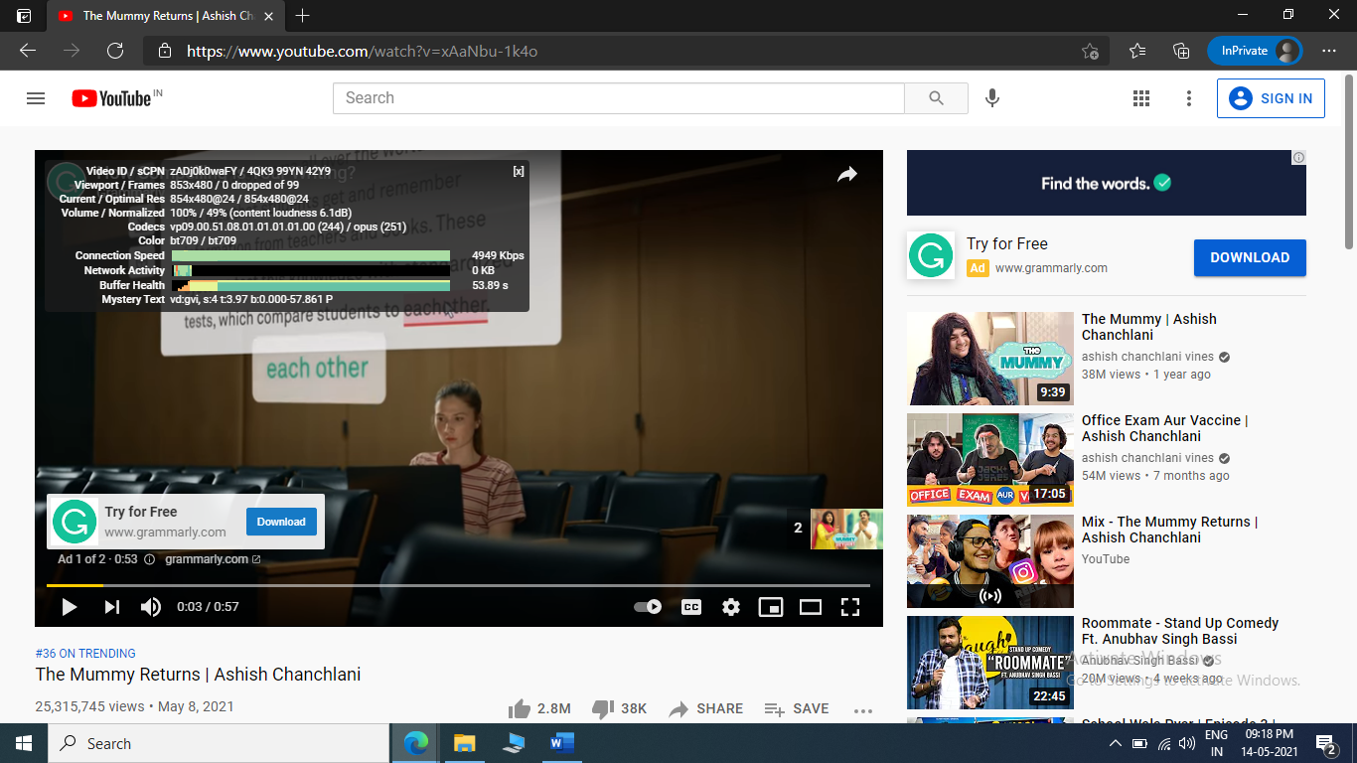

**How To Use Debug Info Feature :**

1. Copy The Debug Info of AD:

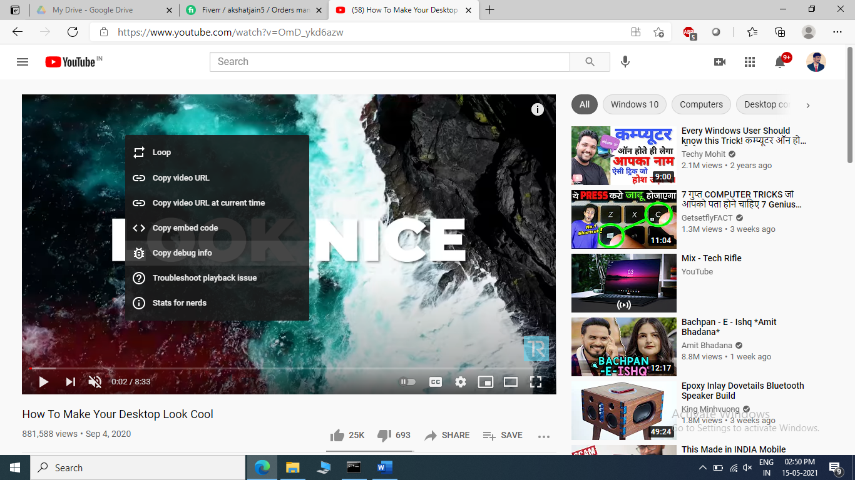

1. Paste this info in “ To Read.txt file “
2. Run Download AD.py or Download AD.exe file
3. Press 3

**Note: Can’t paste directly in terminal as it may cause terminal to misbehave , so safe idea is to write it to .txt file and then read it from there .**

**Download the update executable file from :**

https://drive.google.com/drive/folders/1zEAY5J8Y3jtM11oqNecVipoKpSL0pPDs?usp=sharing